HTML5 – Day-1 Hands On – Srinu
Problem 1. Introduction
1.Problem Statement
Assessment Goal: Check if learners understand basic HTML structure and content creation.
Hands-on Tasks:
1. Create a basic HTML page with proper structure (DOCTYPE, head, body)
2. Add a heading and a paragraph introducing yourself
3. Create an unordered list showing your hobbies
4. Create an ordered list showing daily routine steps
5. Create a simple table showing : Student Name Subject Marks
Expected Outcome:
A static HTML page that displays structured content correctly in the browser.

2.HTML Code
<!DOCTYPE html>
<html lang="en">
<head>
<meta charset="UTF-8">
<meta name="viewport" content="width=device-width, initial-scale=1.0">
<title>About Me</title>
</head>
<body>
<h1>About Me</h1>
<p>Hello I am Srinu FullStack Developer</p>
<h2>Hobbies</h2>
<ul>
<li>heliping to parents</li>
<li>Doing tasks</li>
<li>spending with friends</li>
</ul>
<h2>daily routines</h2>
<ol>
<li>weakup early morining</li>
<li>attending classes</li>
<li>practice coding</li>
</ol>

<h2>student details</h2>
<table border="1">
<tr>
<th>Student name</th>
<th>Subject</th>
<th>Marks(Percentage)</th>
</tr>
<tr>
<td>srinu</td>
<td>maths</td>
<td>90%</td>
</tr>
<tr>
<td>vamsi</td>
<td>English</td>
<td>85%</td>
</tr>
<tr>
<td>Naidu</td>
<td>physics</td>
<td>95%</td>
</tr>
</table>
</body>
</html>
3.Output Screenshot
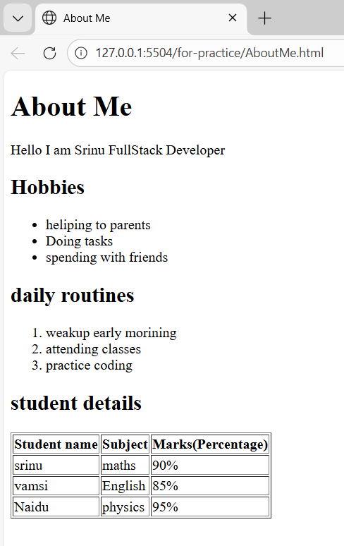

4. Code Explanation
<!DOCTYPE html> Declares the document type and specifies that this is an HTML5 document.
<html lang="en"> Root element of the HTML page. The lang attribute specifies the language.
<head> section Contains metadata like character encoding and page title.
<meta charset="UTF-8"> Ensures proper display of text and special characters.
<meta name="viewport"> Makes the page responsive on different screen sizes.
<title> Defines the title shown on the browser tab.
<body> Contains all visible content of the webpage.
<h1> and <h2> Used to define headings.
<p> Used to display a paragraph of text.
<ul> and <li> Used to create an unordered list of hobbies.
<ol> and <li> Used to create an ordered list of daily routines.
<table> Used to display data in tabular format.
<tr> Defines a table row.
<th> Defines table header cells.
<td> Defines table data cells.
border="1" Adds a border to the table.

Problem 2: Restaurant Menu Webpage (Level-1)
1.Problem Statement
A small restaurant wants a basic menu webpage to display their offerings online before moving to a full website.
Requirements
Create an HTML page that displays Restaurant Name (Heading) About the Restaurant (Paragraph) Menu Categories (Unordered List) Price List (Table) Table Structure Item Name Category Price (₹) Paneer Butter Masala Main Course 220 Veg Biryani Main Course 180 Masala Dosa Breakfast 90 Cold Coffee Beverages 120
2.HTML Code
<!DOCTYPE html>
<html lang="en">
<head>
<meta charset="UTF-8">
<meta name="viewport" content="width=device-width, initial-scale=1.0">
<title>Restaurant Task</title>
</head>
<body>
<h1>Srinu Restaurant</h1>
<p>Welcome to Srinu Restaurant! we serve delicious and fresh food with best quality.</p>
<h2>menu categories</h2>
<ul>
<li>main course</li>
<li>breakfast</li>
<li>beverages</li>
</ul>
<h2>price list</h2>
<table border="2">
<tr>
<th>item name</th>
<th>category</th>
<th>price($)</th>
</tr>
<tr>
<td>paneer butter masala</td>
<td>main course</td>
<td>$200</td>
</tr>
<tr>
<td>veg biryani</td>
<td>main course</td>
<td>$180</td>
</tr>
<tr>
<td>masala dosa</td>
<td>breakfast</td>
<td>$120</td>
</tr>
<tr>
<td>cold coffee</td>
<td>beverages</td>
<td>$120</td>
</tr>
</table>
</body>
</html>

3. Output Screenshot
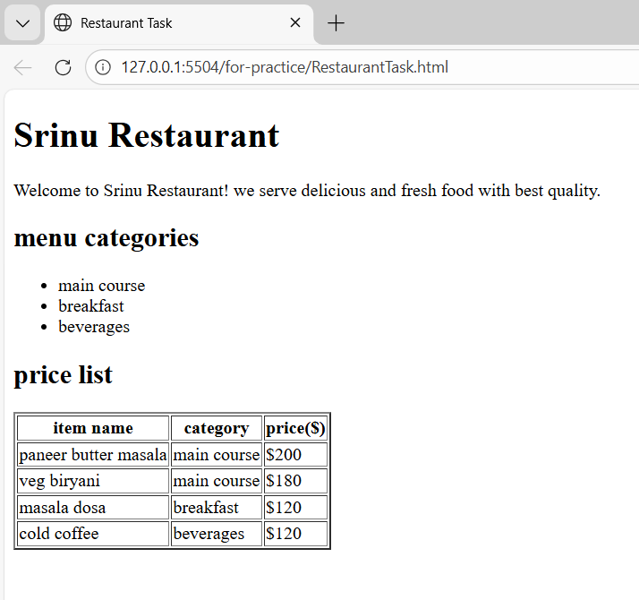
4. Code Explanation
<!DOCTYPE html>Specifies that the document is an HTML5 document.
<html lang="en">Root element of the webpage and specifies English language.
<head>Contains metadata like title and character encoding.
<meta charset="UTF-8">Ensures proper display of characters.
<meta name="viewport">Makes the webpage responsive on all devices.
<title>Displays the title on the browser tab.
<body>Contains all visible webpage content.
<h1>Displays the restaurant name as the main heading.
<p>Displays information about the restaurant.
<ul> and <li>Used to display menu categories in list format.
<table>Used to organize menu items in tabular format.
border="2"Adds border to the table.
<tr>Defines table rows.
<th>Defines table header cells.
<td>Defines table data cells.

Problem 3: Personal Grocery Checklist (Level-1)
1.Problem Statement
You are building a simple webpage for personal use to plan your weekly grocery shopping. The page should clearly show priority items and optional items, so it’s easy to decide what to buy first.
Requirements
Create an HTML webpage that includes: A page title: Weekly Grocery Checklist A main heading displaying the same title. An Ordered List showing high-priority grocery items, such as: Rice Milk Vegetables Cooking Oil An Unordered List showing optional or non-essential items, such as: Snacks Ice cream Soft drinks
2.HTML Code
<!DOCTYPE html>
<html lang="en">
<head>
<meta charset="UTF-8">
<meta name="viewport" content="width=device-width, initial-scale=1.0">
<title>Grocery Checklist</title>
</head>
<body>
<h1>Weekly Grocery Checklist</h1>
<h2>High-priority Items</h2>
<ol>
<li>Rice</li>
<li>milk</li>
<li>Vegetables</li>
<li>Cooking oil</li>
</ol>
<h2>Non-essential Items</h2>
<ul>
<li>Snacks</li>
<li>Ice cream</li>
<li>Soft Drinks</li>
</ul>
</body>
</html>
3.Output Screenshot
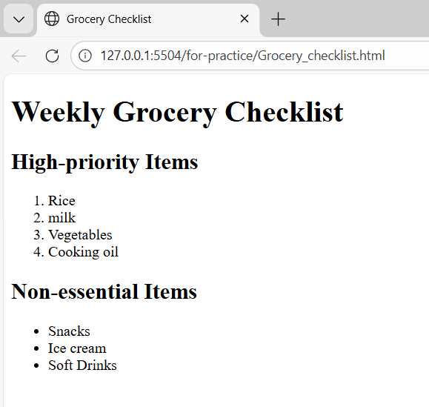

4.Code Explanation
<!DOCTYPE html> Declares the document as HTML5.
<html lang="en"> Root element of the webpage and specifies English language.
<head> Contains metadata and title of the webpage.
<meta charset="UTF-8"> Ensures correct display of characters.
<meta name="viewport"> Makes the webpage responsive on different devices.
<title> Displays the title on the browser tab.
<body> Contains all visible content of the webpage.
<h1> Displays the main heading of the page.
<h2> Displays section headings.
<ol> Creates an ordered list for high-priority items.
<ul> Creates an unordered list for optional items.
<li> Defines individual list items.

Problem 4: Employee Onboarding Page (Level-2)
1.Problem Statement
A company wants a basic onboarding page for new employees that HR can later style using CSS.
Requirements
Use Semantic HTML: <header> → Company name & welcome message <section> → Employee details <article> → Company policies <footer> → Contact information Content Structure Employee Information (Table) Employee ID Name Department Joining Date Company Policies (Ordered List) Working hours Leave policy Code of conduct Facilities Provided (Unordered List) Laptop Internet access Training materials.
2.HTML Code
<!DOCTYPE html>
<html lang="en">
<head>
<meta charset="UTF-8">
<meta name="viewport" content="width=device-width, initial-scale=1.0">
<title>Employee Onboarding Page</title>
</head>
<body>
<header>
<h1>Upgrade</h1>
<p>Welcome to Upgrade. We are exicited to have you join out team!</p>
</header>

<section>
<h2>Employee Information</h2>
<table border="2">
<tr>
<th>Employee Id</th>
<th>Name</th>
<th>Department</th>
<th>Joining Date</th>
</tr>
<tr>
<td>EMP1</td>
<td>Srinu</td>
<td>Software Development</td>
<td>16 Feb 2026</td>
</tr>
</table>
</section>

<article>
<h2>Company Policies</h2>
<h3>Policies List</h3>
<ol>
<li>Working hours: 9:30 AM to 6:30 PM</li>
<li>Leave Policies: 12 casual leaves per year</li>
<li>Code of conduct: Maintain Professionalism</li>
</ol>

<h3>Facilities Provided</h3>
<ul>
<li>Laptop</li>
<li>Internet access</li>
<li>Training Materials</li>
</ul>
</article>

<footer>
<h2>Contact Information</h2>
<address>
Email: upgrade@gmail.Com <br>
phone: +91 9876543210 <br>
Location: Hyderabad, India
</address>
</footer>
</body>
</html>
3.Code Screenshot
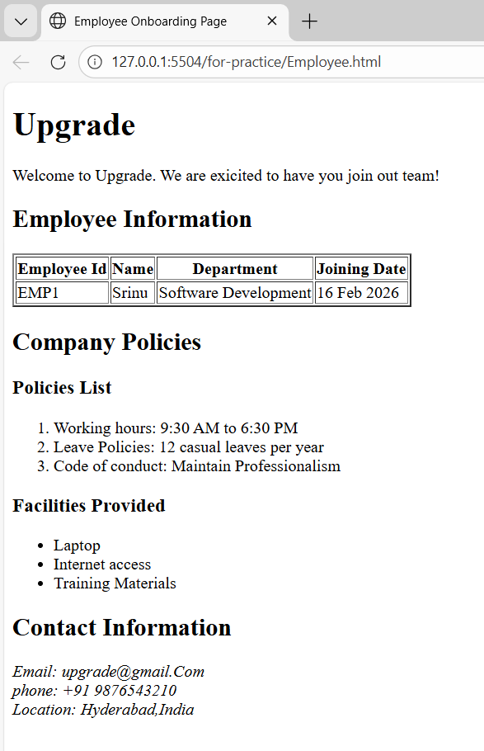
4.Code Explanation:

4.Code Explanation
<!DOCTYPE html> Declares the document as HTML5.
<html lang="en"> Root element of the webpage and specifies English language.
<head> Contains metadata and webpage title.
<title> Displays the title in the browser tab.
<body> Contains all visible content.
<header> Represents the top section containing company name and welcome message.
<section> Represents a separate section containing employee information.
<table> Displays employee data in tabular format.
<tr> Defines table rows.
<th> Defines table header cells.
<td> Defines table data cells.
<article> Represents independent content such as company policies.
<ol> Creates an ordered list for company policies.
<ul> Creates an unordered list for facilities provided.
<footer> Represents the bottom section containing contact information.
<address> Provides contact details of the company.

Problem 5: College Department Information Page (Level-2)
1.Problem Statement
A college wants to create a basic informational webpage for one of its departments (e.g., Computer Science, Information Technology). The page will be used by students and parents to understand faculty details, subjects offered, and the weekly timetable before the site is enhanced with CSS and backend features.
Requirements
Create an HTML webpage that includes the following sections: Header Department Name College Name Section 1: Faculty Details Display faculty information in a table with columns: Faculty Name Designation Subject Handled Section 2: Subjects Offered Display the list of subjects using an unordered list Section 3: Weekly Timetable Display timetable details in a table with columns: Day Subject Time Slot Footer College address Contact information.
2.HTML Code
<!DOCTYPE html>
<html lang="en">
<head>
<meta charset="UTF-8">
<title>Computer Science Department - College Information</title>
</head>
<body>
<header>
<h1 title="Department Name">Computer Science Department</h1>
<h2 title="College Name">PVR Engineering College</h2>
</header>
<section>
<h3>Faculty Details</h3>
<table border="1">
<tr>
<th>Faculty Name</th>
<th>Designation</th>
<th>Subject Handled</th>
</tr>
<tr>
<td>Dr. Rajesh Kumar</td>
<td>Professor</td>
<td>Data Structures</td>
</tr>
<tr>
<td>Mrs. Anitha Reddy</td>
<td>Associate Professor</td>
<td>Database Management Systems</td>
</tr>
<tr>
<td>Mr. Suresh Babu</td>
<td>Assistant Professor</td>
<td>Operating Systems</td>
</tr>
</table>
</section>
<section>
<h3>Subjects Offered</h3>
<ul title="List of Subjects">
<li>Programming in C</li>
<li>Data Structures</li>
<li>Database Management Systems</li>
<li>Operating Systems</li>
<li>Computer Networks</li>
<li>Software Engineering</li>
</ul>
</section>
<section>
<h3>Weekly Timetable</h3>
<table border="1">
<tr>
<th>Day</th>
<th>Subject</th>
<th>Time Slot</th>
</tr>
<tr>
<td>Monday</td>
<td>Data Structures</td>
<td>9:00 AM - 10:00 AM</td>
</tr>
<tr>
<td>Tuesday</td>
<td>DBMS</td>
<td>10:00 AM - 11:00 AM</td>
</tr>
<tr>
<td>Wednesday</td>
<td>Operating Systems</td>
<td>11:00 AM - 12:00 PM</td>
</tr>
<tr>
<td>Thursday</td>
<td>Computer Networks</td>
<td>1:00 PM - 2:00 PM</td>
</tr>
<tr>
<td>Friday</td>
<td>Software Engineering</td>
<td>2:00 PM - 3:00 PM</td>
</tr>
</table>
</section>
<footer>
<h2>Contact Information</h2>
<address>
PVR Engineering College <br>
Phone: +91 9876543210<br>
Email: info@pvrengineeringcollege.com
</address>
</footer>
</body>
</html>

3.Output Screenshot
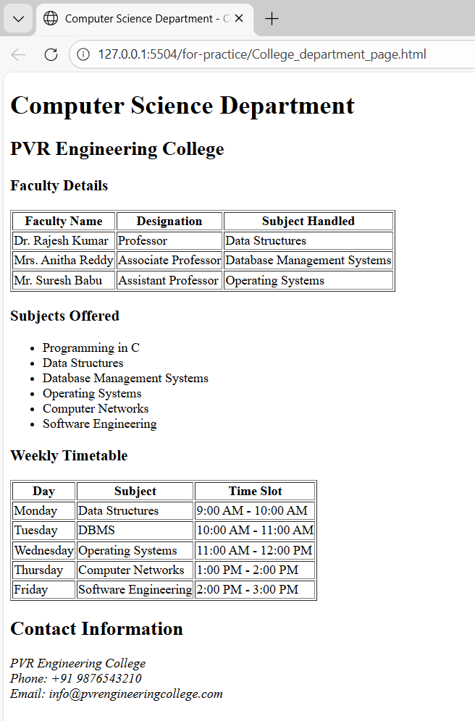

4.Code Explanation
<!DOCTYPE html>Declares the document as HTML5.
<html lang="en">Root element and specifies English language.
<head>Contains metadata and page title.
<title>Displays webpage title on browser tab.
<body>Contains all visible webpage content.
<header>Displays department name and college name.
<section>Groups related content like faculty details, subjects, and timetable.
<table>Displays structured information in rows and columns.
<tr>Defines table rows.
<th>Defines table header cells.
<td>Defines table data cells.
<ul>Creates unordered list of subjects.
<li>Defines list items.
<footer>Displays contact and address information.
<address>Provides contact details of the college.

